**LEBANESE AMERICAN UNIVERSITY**

**USAID – HIGHER EDUCATION SCHOLARSHIP PROGRAM**

**HES - Volunteering Program Verification Form**

This form is to be used to document volunteering hours. If a student volunteers for multiple organizations, a separate form must be used for each organization. **This form must be turned in by the 28th of each month, the latest.**

I certify that the scholar Mariam Ahmad Rabeh completed a total of 5 hours of service at InnovaThrive.

The hours were completed hours as per the below:

Hours # 0 (date) _2/12 – 6/12_ (initials of supervisor) __A.K.___

Hours # 0 (date) _9/12 – 13/12_ (initials of supervisor) __A.K.___

Hours # 5 date) _16/12 – 20/12 (initials of supervisor) __A.K.___

Hours # 0 date) _23/12 - 27/12 (initials of supervisor) __A.K.___

Brief description of the activities the scholar performed or participated in:

I conducted research on The Role of Blockchain in Authenticating Digital Art, focusing on how blockchain technology establishes ownership and provenance for digital artworks. I explored key technologies, such as non-fungible tokens (NFTs), which enable art ownership, and smart contracts, which handle licensing and royalties.  
  
My study examined various applications, including verifying the authenticity of digital creations and facilitating fractional ownership for high-value art pieces. Supporting statistics highlighted the NFT market's rapid growth of 250% from 2020 to 2023.  
  
I also analyzed the advantages of blockchain in the art world, such as automated royalty payments for artists and immutable records of ownership and transactions. However, I addressed the disadvantages, notably the environmental impact caused by blockchain technologies.  
  
In discussing challenges, I explored issues like copyright disputes in the digital landscape. Finally, I proposed directions for future research, such as developing eco-friendly blockchain solutions for the art industry and expanding NFTs to preserve cultural heritage and historical artworks.

Written feedback about the scholar’s performance:

Mariam demonstrated excellent research and critical thinking skills by exploring blockchain’s role in digital art authentication, highlighting innovative applications like NFTs and proposing eco-friendly solutions.

Please rate the overall performance of the scholar at your organization:

|  |  |  |  |
| --- | --- | --- | --- |
|  | Mastery (5) | Proficient (3) | Emerging (1) |
| **Problem solver** | X |  |  |
| **Engaged & Committed** | X |  |  |
| **Open-minded & multicultural** | X |  |  |

Signature

& stamp

__________________________

_

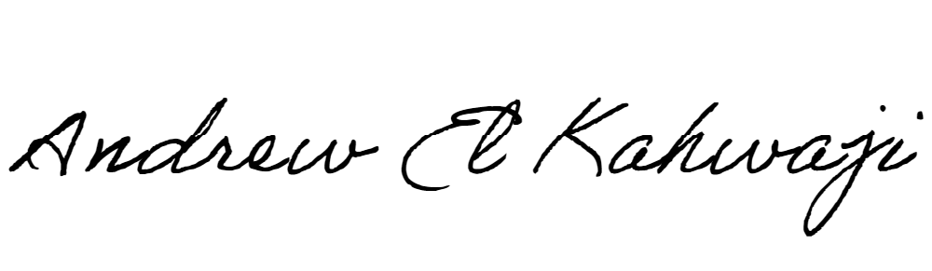

Printed Name _Andrew El Kahwaji_

Date __26/12/2024___

Email __andrew.lifesculptor.coo@gmail.com __

Phone __+961 71 914 378__